Hacking with powershell

Now that we've understood how *cmdlets* works - let's explore how to use them! The main thing to remember here is that Get-Command and Get-Help are your best friends!

Using Get-Help

Get-Help displays information about a *cmdlet.*To get help about a particular command, run the following:

Get-Help Command-Name

You can also understand how exactly to use the command by passing in the -examples flag. This would return output like the following:

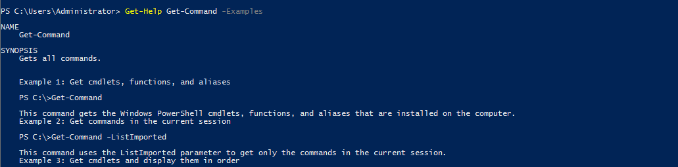

Using Get-Command

Get-Command gets all the *cmdlets*installed on the current Computer. The great thing about this *cmdlet* is that it allows for pattern matching like the following

Get-Command Verb-* or Get-Command *-Noun

Running Get-Command New-* to view all the *cmdlets* for the verb new displays the following:

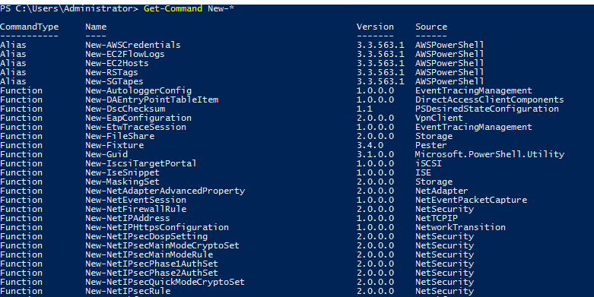

Object Manipulation

In the previous task, we saw how the output of every *cmdlet* is an object. If we want to actually manipulate the output, we need to figure out a few things:

* passing output to other *cmdlets*
* using specific object *cmdlets* to extract information

The Pipeline(|) is used to pass output from one *cmdlet* to another. A major difference compared to other shells is that instead of passing text or string to the command after the pipe, powershell passes an object to the next cmdlet. Like every object in object oriented frameworks, an object will contain methods and properties. You can think of methods as functions that can be applied to output from the *cmdlet* and you can think of properties as variables in the output from a cmdlet. To view these details, pass the output of a *cmdlet* to the Get-Member *cmdlet*

Verb-Noun | Get-Member

An example of running this to view the members for Get-Command is:

Get-Command | Get-Member -MemberType Method

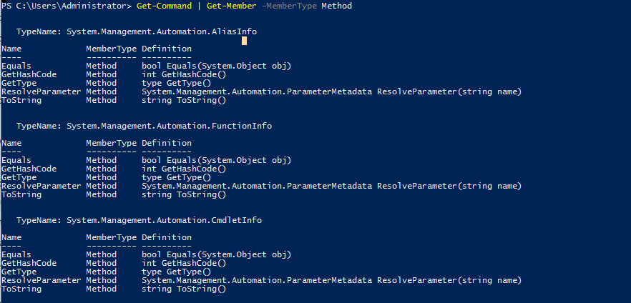

From the above flag in the command, you can see that you can also select between methods and properties.

Creating Objects From Previous *cmdlets*

One way of manipulating objects is pulling out the properties from the output of a cmdlet and creating a new object. This is done using the Select-Object *cmdlet.*

Here's an example of listing the directories and just selecting the mode and the name:

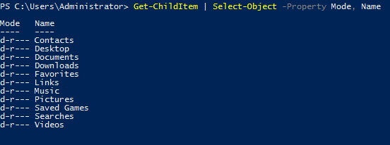

You can also use the following flags to select particular information:

* first - gets the first x object
* last - gets the last x object
* unique - shows the unique objects
* skip - skips x objects

Filtering Objects

When retrieving output objects, you may want to select objects that match a very specific value. You can do this using the Where-Object to filter based on the value of properties.

The general format of the using this *cmdlet* is

Verb-Noun | Where-Object -Property PropertyName -operator Value

Verb-Noun | Where-Object {$_.PropertyName -operator Value}

The second version uses the $_ operator to iterate through every object passed to the Where-Object cmdlet.

**Powershell is quite sensitive so make sure you don't put quotes around the command!**

Where -operator is a list of the following operators:

* -Contains: if any item in the property value is an exact match for the specified value
* -EQ: if the property value is the same as the specified value
* -GT: if the property value is greater than the specified value

For a full list of operators, use [this](https://docs.microsoft.com/en-us/powershell/module/microsoft.powershell.core/where-object?view=powershell-6) link.

Here's an example of checking the stopped processes:

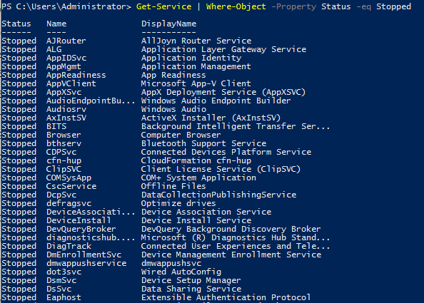

Sort Object

When a *cmdlet*outputs a lot of information, you may need to sort it to extract the information more efficiently. You do this by pipe lining the output of a *cmdlet* to the Sort-Object *cmdlet*.

The format of the command would be

Verb-Noun | Sort-Object

Here's an example of sort the list of directories:

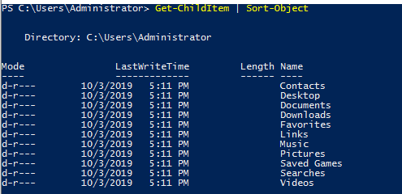

Now that you've understood the basics of how Powershell works, let try some commands to apply this knowledge!

***Answer the questions below***

What is the location of the file "interesting-file.txt"

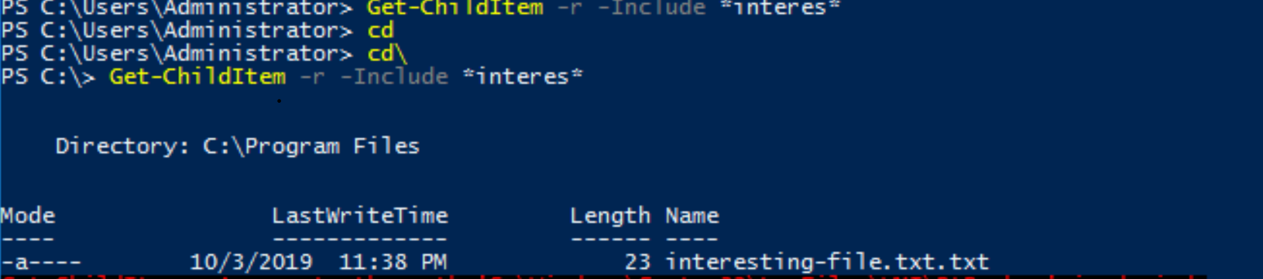Specify the contents of this file



How many cmdlets are installed on the system(only cmdlets, not functions and aliases)?

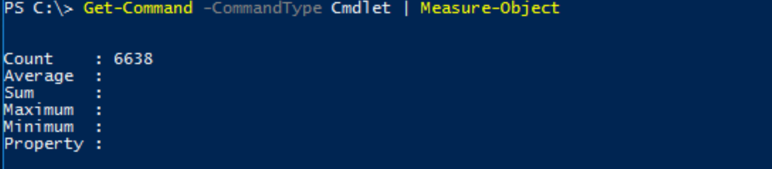Get the MD5 hash of interesting-file.txt

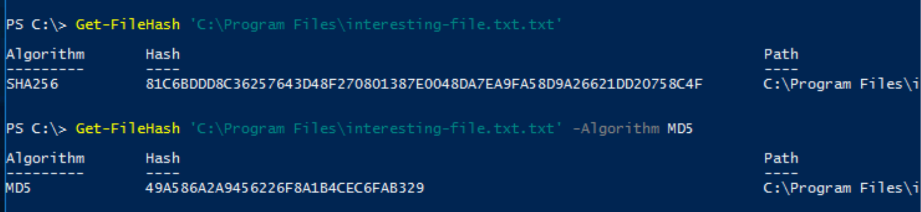What is the command to get the current working directory?

Does the path "C:\Users\Administrator\Documents\Passwords" Exist(Y/N)?

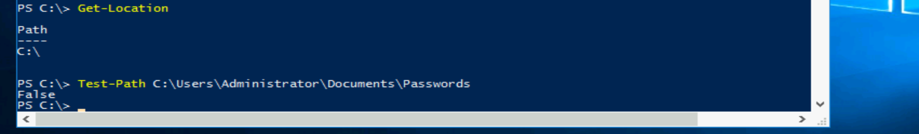What command would you use to make a request to a web server?

invoke-Webrequest

Base64 decode the file b64.txt on Windows.

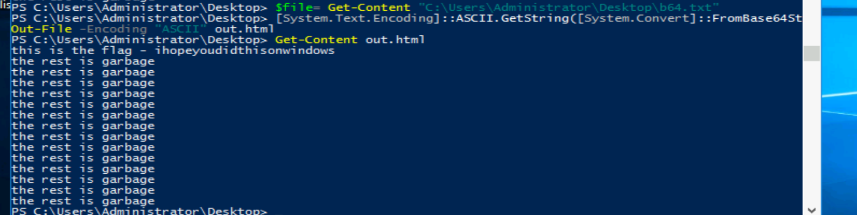

Enumeration

The first step when you have gained initial access to any machine would be to enumerate. We'll be enumerating the following:

* users
* basic networking information
* file permissions
* registry permissions
* scheduled and running tasks
* insecure files

Your task will be to answer the following questions to enumerate the machine using Powershell commands!

***Answer the questions below***

How many users are there on the machine?

5 users account

Which local user does this SID(S-1-5-21-1394777289-3961777894-1791813945-501) belong to?

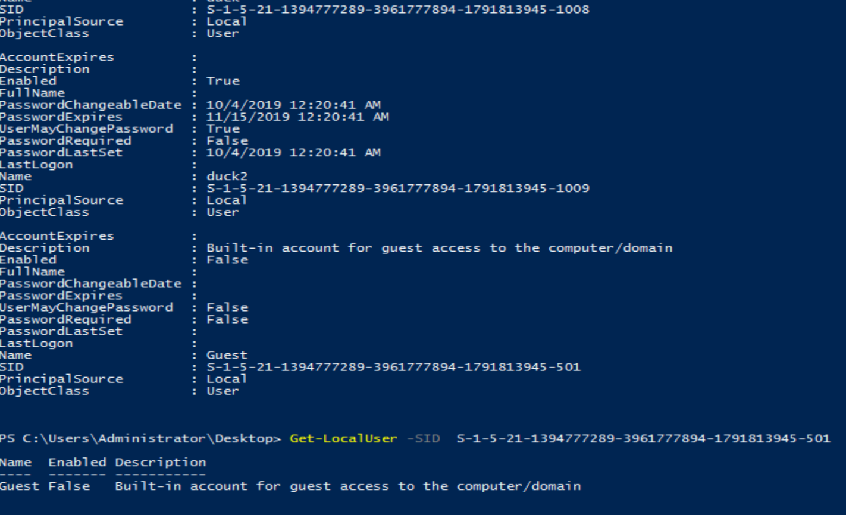How many users have their password required values set to False?

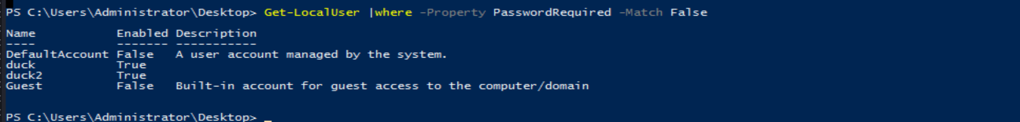How many local groups exist?

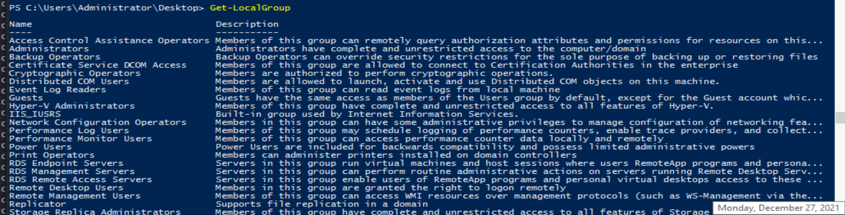

What command did you use to get the IP address info?

Get-NetIPAddress

How many ports are listed as listening?

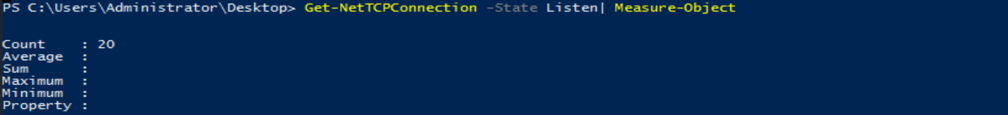

What is the remote address of the local port listening on port 445?

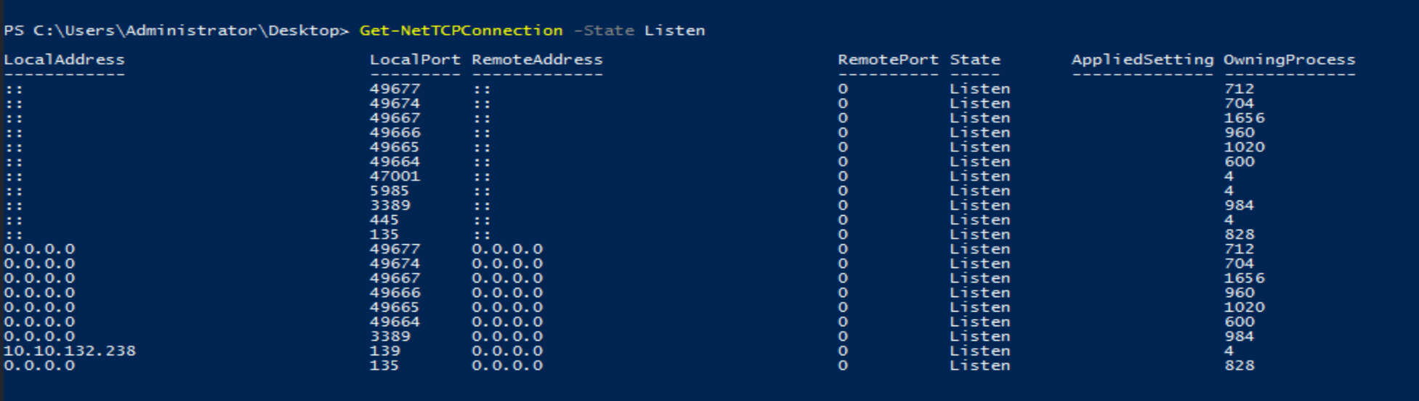

How many patches have been applied?

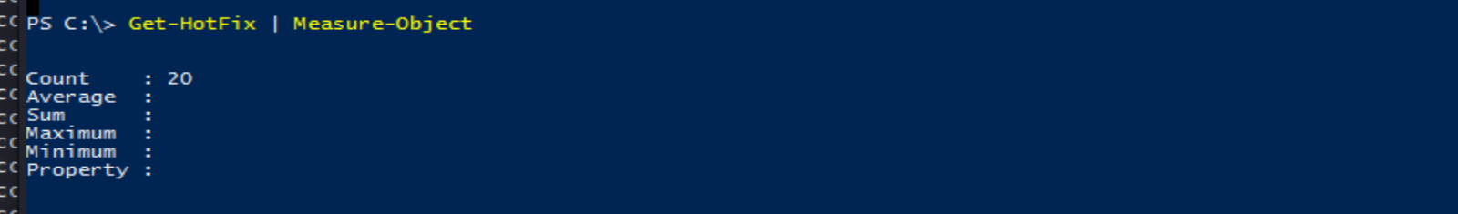

When was the patch with ID KB4023834 installed?

Find the contents of a backup file.

-**Mind the exact path for the file

Search for all files containing API_KEY

Use following cmd

Get-ChildItem -Recurse | Select-String "API_Key" -List

What command do you do to list all the running processes?

Get-Process

What is the path of the scheduled task called new-sched-task?



Who is the owner of the C:\

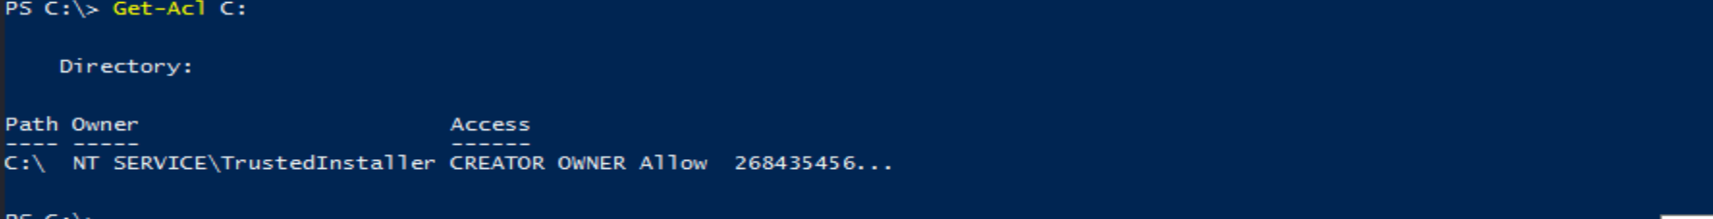

Basic Scripting

Now that we have run powershell commands, let's actually try write and run a script to do more complex and powerful actions.

For this ask, we'll be using PowerShell ISE(which is the Powershell Text Editor). To show an example of this script, let's use a particular scenario. Given a list of port numbers, we want to use this list to see if the local port is listening. Open the listening-ports.ps1 script on the Desktop using Powershell ISE. Powershell scripts usually have the *.ps1*file extension.

$system_ports = Get-NetTCPConnection -State Listen

$text_port = Get-Content -Path C:\Users\Administrator\Desktop\ports.txt

foreach($port in $text_port){

if($port -in $system_ports.LocalPort){

echo $port

}

}

On the first line, we want to get a list of all the ports on the system that are listening. We do this using the Get-NetTCPConnection *cmdlet*. We are then saving the output of this *cmdlet* into a variable. The convention to create variables is used as:

$variable_name = value

On the next line, we want to read a list of ports from the file. We do this using the Get-Content *cmdlet.*Again, we store this output in the variables. The simplest next step is iterate through all the ports in the file to see if the ports are listening. To iterate through the ports in the file, we use the following

foreach($new_var in $existing_var){}

This particular code block is used to loop through a set of object. Once we have each individual port, we want to check if this port occurs in the listening local ports. Instead of doing another for loop, we just use an if statement with the -in operator to check if the port exists the LocalPort property of any object. A full list of if statement comparison operators can be found [here](https://docs.microsoft.com/en-us/powershell/module/microsoft.powershell.core/about/about_comparison_operators?view=powershell-6). To run script, just call the script path using Powershell or click the green button on Powershell ISE:

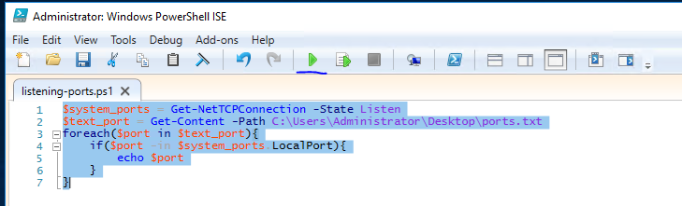

Now that we've seen what a basic script looks like - it's time to write one of your own. The emails folder on the Desktop contains copies of the emails John, Martha and Mary have been sending to each other(and themselves). Answer the following questions with regards to these emails(try not to open the files and use a script to answer the questions).

Scripting may be a bit difficult, but [here](https://learnxinyminutes.com/docs/powershell/) is a good resource to use:

***Answer the questions below***

What file contains the password?

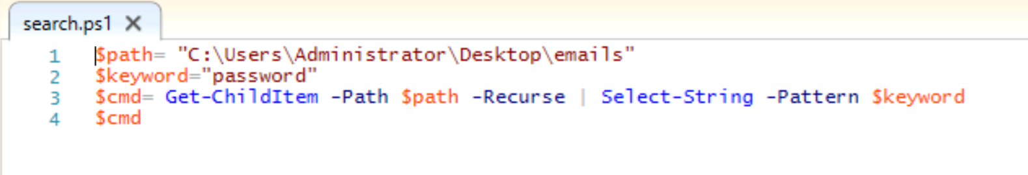

What is the password?

Keep in mind to give whole path to your script

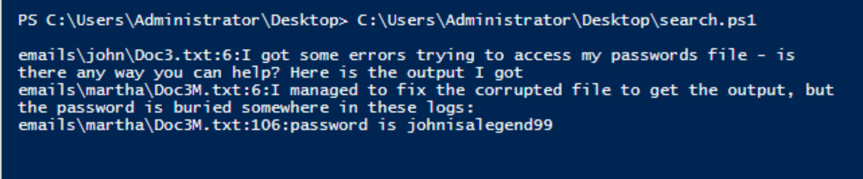What files contains an HTTPS link?

Just change the keyword to http



Now that you've learnt a little bit about how scripting works - let's try something a bit more interesting. Sometimes we may not have utilities like nmap and python available, and we are forced to write scripts to do very rudimentary tasks. Why don't you try writing a simple port scanner using Powershell. Here's the general approach to use:

* Determine IP ranges to scan(in this case it will be localhost) and you can provide the input in any way you want
* Determine the port ranges to scan
* Determine the type of scan to run(in this case it will be a simple TCP Connect Scan)

***Answer the questions below***

How many open ports did you find between 130 and 140(inclusive of those two)

